**1. What is SDLC?**

SDLC (software devlopment life cycle) Cycle represents the process of developing software. SDLC framework includes the following steps:

1. Requirements Collection/Gathering Phase
2. Analysis Phase
3. Design Phase
4. Implementation Phase
5. Testing Phase
6. Maintenance Phase

**2. What is software testing?**

Software testing is a process of identifying the correctness of software by considering its all attributes (Reliability, Scalability, Portability, Re-usability, Usability) and evaluating the execution of software components to find the software bug or errors or defects.

**3. What is agile methodology?**

An agile methodology is an iterative approach to software development. Each iteration of agile methodology takes a short time interval of 1 to 4 weeks. The agile development process is aligned to deliver the changing business requirement. It distributes the software with faster and fewer changes.

The single-phase software development takes 6 to 18 months. In single-phase development, all the requirement gathering and risks management factors are predicted initially.

The agile software development process frequently takes the feedback of workable product. The workable product is delivered within 1 to 4 weeks of iteration.

## 

**4. What is SRS?**

A software requirements specification (SRS) is a complete description of the behavior of the system to be developed.

It includes a set of use cases that describe all of the interactions that the users will have with the software.

The SRS also contains nonfunctional (or supplementary) requirements.

**5. What is OOPS?**

An object-based programming language is one which easily supports

object-orientation. Identifying objects and assigning responsibilities to these objects. Objects communicate to other objects by sending messages. Messages are received by the methods of an object. An object is like a black box. The internal details are hidden.

**6. Write Basic Concepts of OOPS?**

**Concepts of OOPS: -**

**•** Object

• Class

• Encapsulation

• Inheritance

• Polymorphism

•Overriding

•Overloading

• Abstraction

**7. What is object?**

An object represents an individual, identiﬁable item, unit, or entity. either real or abstract, with a well-deﬁned role in the problem domain. An "object" is anything to which a concept applies. This is the basic unit of object-oriented programming (OOP). That is both data and function that operate on data are bundled as a unit called as object.

**8. What is class?**

The building block of that leads to Object-Oriented programming is a Class. It is a user-defined data type, which holds its own data members and member functions, which can be accessed and used by creating an instance of that class. A class is like a blueprint for an object.

**9. What is Encapsulation?**

Encapsulation is the practice of including in an object everything it needs hidden from other objects. The internal state is usually not accessible by other objects.

**10. What is inheritance?**

Inheritance means that one class inherits the characteristics of another class. This is also called a “is a” relationship.

Inheritance describes the relationship between two classes. A class can get some of its characteristics from a parent class and then add unique features of its own.

**11. What is Polymorphism?**

The word “polymorphism” means having many forms. In simple words, we can define polymorphism as the ability of a message to be displayed in more than one form. A real-life example of polymorphism is a person who at the same time can have different characteristics. A man at the same time is a father, a husband, and an employee. So, the same person exhibits different behavior in different situations. This is called polymorphism. Polymorphism is considered one of the important features of Object-Oriented Programming.

## Types of Polymorphism

* **Compile-time Polymorphism (Overloading)**
* **Runtime Polymorphism (Overriding)**

**12. Draw Use case on Online book shopping.**

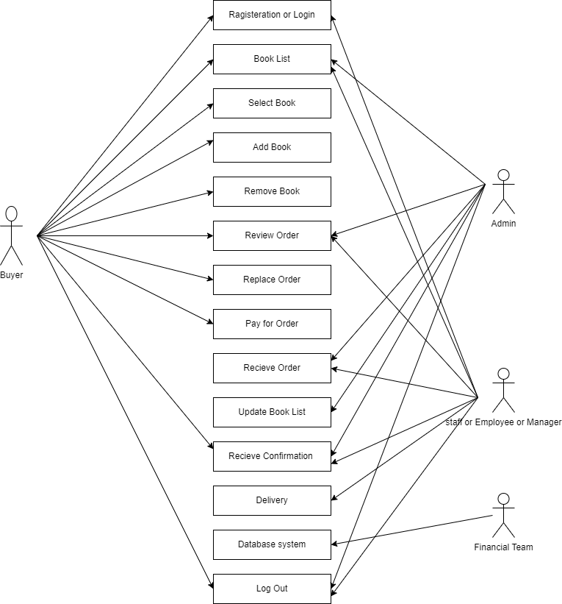

**13. Draw Use case on online bill payment system(Paytm).**

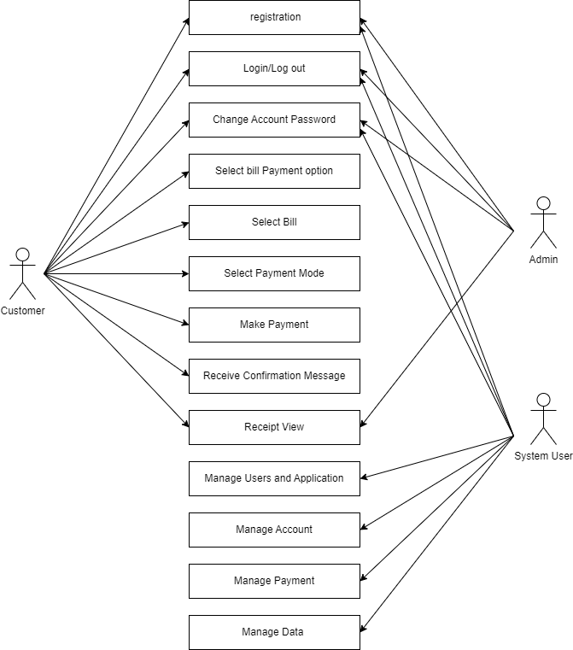

**14. Write SDLC Phases with basic introduction.**

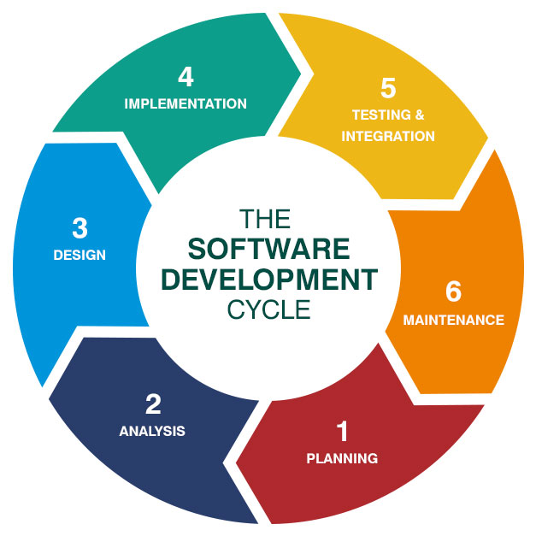

**1. Requirements Collection Phase: -**

Planning is the crucial step in everything and so as in software development. In this same stage, requirement analysis is also performed by the developers of the organization. This is attained from the inputs from the customers, sales department/market surveys. The information from this analysis forms the building block of a basic project. The quality proof of the project is a result of planning. Thus, in this stage, the basic project is designed with all the available information.

**2. Analysis Phase: -**

In this stage, all the requirements for the target software are specified. These requirements get approval from the customers, market analysts, and stakeholders. This is a sort of document that specifies all those things that need to be defined and created during the entire project cycle.

**3. Design Phase: -**

SRS is a reference for software designers to come out with the best architecture for the software. Hence, with the requirements defined in SRS, multiple designs for the product architecture are present in the Design Document Specification (DDS).   
This DDS is assessed by market analysts and stakeholders. After evaluating all the possible factors, the most practical and logical design is chosen for the development.

**4. Implementation Phase: -**

At this stage, the fundamental development of the product starts. For this, developers use a specific programming code as per the design in the DDS. Hence, it is important for the coders to follow the protocols set by the association. Conventional programming tools like compilers, interpreters, debuggers, etc. are also put into use at this stage. Some popular languages like C/C++, Python, Java, etc. are put into use as per the software regulations.

**5. Testing Phase: -**

After the development of the product, testing of the software is necessary to ensure its smooth execution. Although, minimal testing is conducted at every stage of SDLC.

Therefore, at this stage, all the probable flaws are tracked, fixed, and retested. This ensures that the product confronts the quality requirements of SRS.

**6. Maintenace Phase: -**

After detailed testing, the conclusive product is released in phases as per the organization’s strategy. Then it is tested in a real industrial environment. Because it is important to ensure its smooth performance. If it performs well, the organization sends out the product as a whole. After retrieving beneficial feedback, the company releases it as it is or with auxiliary improvements to make it further helpful for the customers. However, this alone is not enough. Therefore, along with the deployment, the product’s supervision.

**15. Explain Phases of waterfall model.**

Waterfall approach was first SDLC Model to be used widely in Software Engineering to ensure success of the project. In "The Waterfall" approach, the whole process of software development is divided into separate phases. In this Waterfall model, typically, the outcome of one phase acts as the input for the next phase sequentially.

The following illustration is a representation of the different phases of the Waterfall Model.

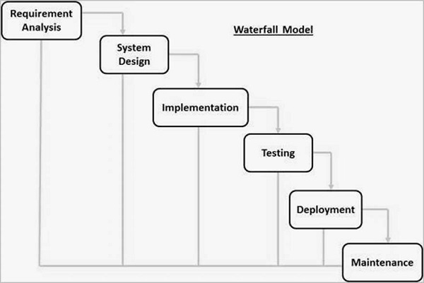

The sequential phases in Waterfall model are −

* **Requirement Gathering and analysis** − All possible requirements of the system to be developed are captured in this phase and documented in a requirement specification document.
* **System Design** − The requirement specifications from first phase are studied in this phase and the system design is prepared. This system design helps in specifying hardware and system requirements and helps in defining the overall system architecture.
* **Implementation** − With inputs from the system design, the system is first developed in small programs called units, which are integrated in the next phase. Each unit is developed and tested for its functionality, which is referred to as Unit Testing.
* **Integration and Testing** − All the units developed in the implementation phase are integrated into a system after testing of each unit. Post integration the entire system is tested for any faults and failures.
* **Deployment of system** − Once the functional and non-functional testing is done; the product is deployed in the customer environment or released into the market.
* **Maintenance** − There are some issues which come up in the client environment. To fix those issues, patches are released. Also to enhance the product some better versions are released. Maintenance is done to deliver these changes in the customer environment.

**16. Write Phases of spiral model.**

The spiral model, initially proposed by Boehm, is an evolutionary software process model that couples the iterative feature of prototyping with the controlled and systematic aspects of the linear sequential model. It implements the potential for rapid development of new versions of the software. Using the spiral model, the software is developed in a series of incremental releases. During the early iterations, the additional release may be a paper model or prototype. During later iterations, more and more complete versions of the engineered system are produced.

**Each cycle in the spiral is divided into four parts:**

**Objective setting:** Each cycle in the spiral starts with the identification of purpose for that cycle, the various alternatives that are possible for achieving the targets, and the constraints that exists.

**Risk Assessment and reduction:** The next phase in the cycle is to calculate these various alternatives based on the goals and constraints. The focus of evaluation in this stage is located on the risk perception for the project.

**The Spiral Model is shown in fig:**

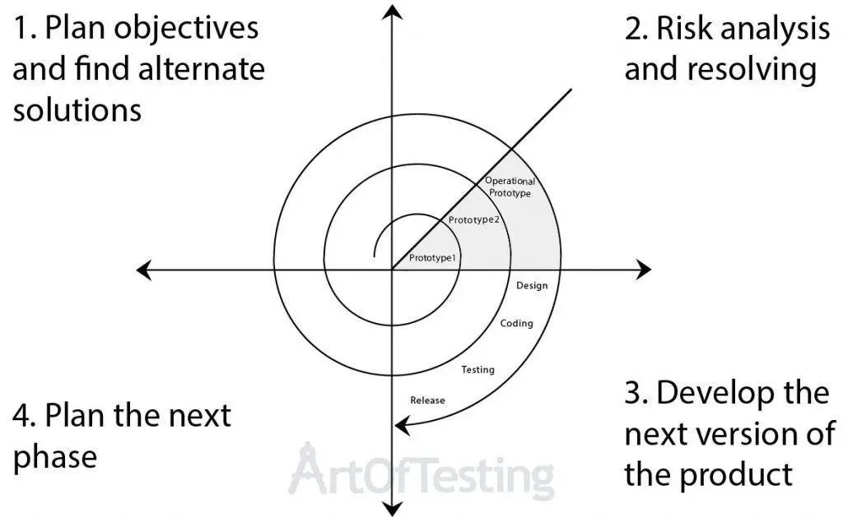

**Development and validation:** The next phase is to develop strategies that resolve uncertainties and risks. This process may include activities such as benchmarking, simulation, and prototyping.

**Planning:** Finally, the next step is planned. The project is reviewed, and a choice made whether to continue with a further period of the spiral. If it is determined to keep, plans are drawn up for the next step of the project.

**17. Draw use case on online shopping product using COD.**

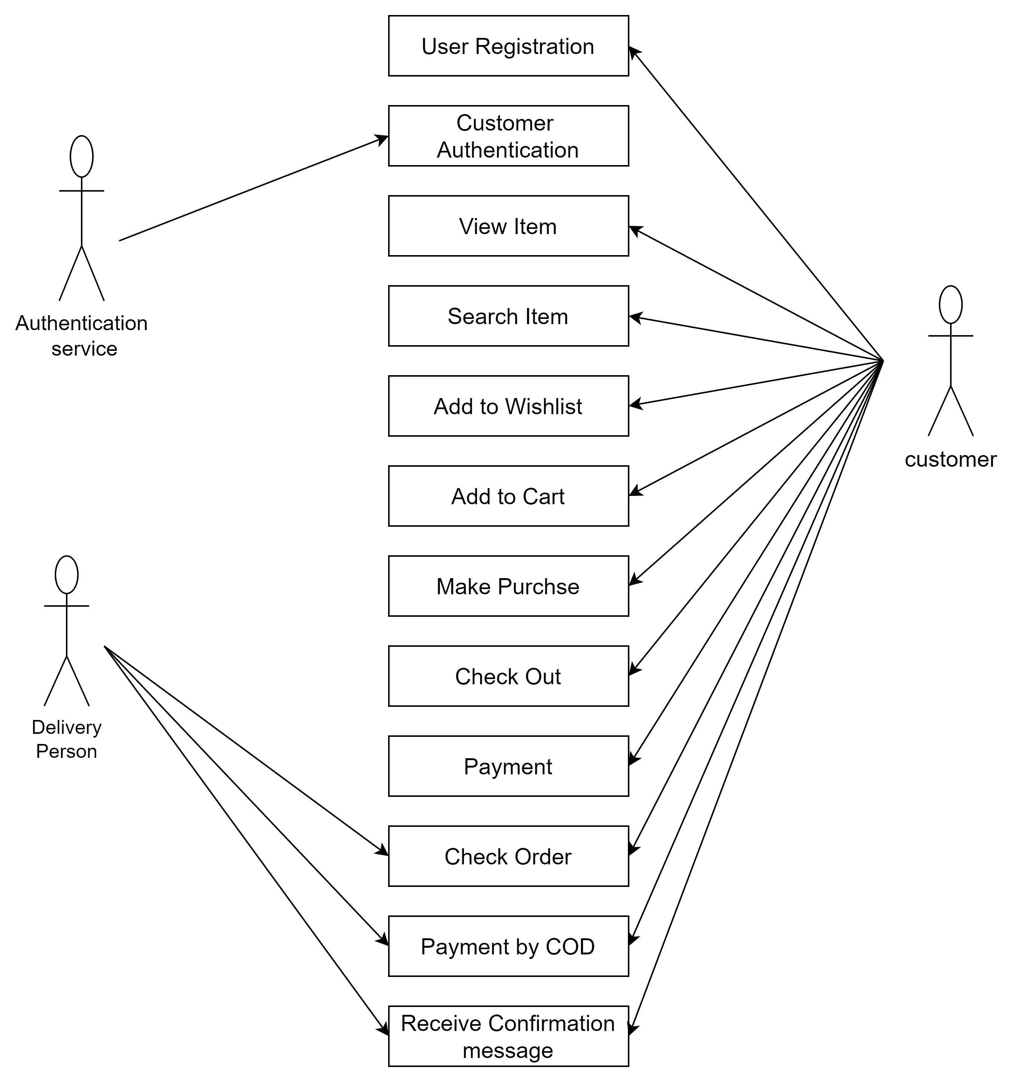

**18. Draw use case online shopping product using payment gateway.**

